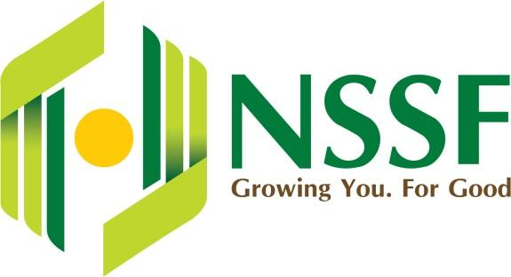 | Questions for the World Bank Group  APIF–WBG JCAP meeting with pension fund leadership | October 2026  NSSF Risk Management | STRICTLY CONFIDENTIAL

Where APIF stands
AIIM (equity) and Ninety One (debt) are shortlisted; no manager is approved and no member is committed. Key dates: 30 Oct due diligence pass/fail • 30 Nov national approvals • 30 Dec Investment Management Agreement • 31 Mar 2027 USD 600m first close.
Main tension: the deck’s 100-day diligence plan cannot finish before the 30 October gate. Gaps in the deck: currency risk, RBA treatment, WBG’s own capital, and who pays for the PCV and diligence.
Priority questions
# | Question | Why it matters to NSSF
1 | Gate scope: What does the 30 Oct "due diligence test" decide? Which workstreams will be complete and which carry over to the IMA? | A pass on partial diligence must not be read as full clearance.
2 | WBG capital: Will IFC, MIGA or the WB commit capital, first-loss, guarantees or hedging? How much, and at which close? | A DFI anchor improves terms; its absence is a signal.
3 | Currency: What hedging or KES options exist, and what does a 30% KES fall do to the net return? | NSSF liabilities are in KES; the fund is in USD.
4 | RBA treatment: Has RBA confirmed how a Mauritius- or EADB-domiciled fund counts against NSSF’s investment limits? | Wrong classification risks breaching RBA limits.
5 | Approvals: Which NSSF approvals (Board, National Treasury, RBA) does the Kenya action plan list, and can they be met by 30 Nov on draft terms? | Approving draft terms creates re-approval risk.
6 | Ticket and fallback: What commitment does USD 600m assume per member, and what happens if it is missed: smaller close, extension or abort? | Exposure to a sub-scale fund and sunk costs.
7 | PCV: What is its budget, funding, staffing and cost share? Does any liability reach NSSF’s trustees? | Fiduciary duty stays with the NSSF Board.
8 | Total cost: What is the all-in yearly cost (fees, carry, PCV, expenses, hedging) as % of committed and invested capital? | One number for the Investment Committee.
9 | Terms: Can members see each manager’s term sheet (fees, hurdle, carry basis, GP commitment, escrow) against the ILPA checklist? | Cannot test terms without seeing them.
10 | Risk evidence: Will the WBG share base, downside and stress scenarios (FX, construction delay, asset default) and the capital-call schedule? | Quantified downside and liquidity planning.
11 | Conflicts: What ties do IFC or the WBG have with AIIM, Ninety One or the pipeline assets, and how are they disclosed? | The WBG advises members and may invest alongside.
12 | Pipeline: What share is greenfield vs operating, by country and sector, and what concentration limits apply? | Early binary losses on single greenfield assets.
Support to request from the WBG
Request | Needed by
Funding for independent Kenyan legal and tax counsel for NSSF | 15 Nov 2026
Scenario and liquidity model per USD 10m committed, in KES and USD | 15 Nov 2026
Joint JCAP–NSSF engagement with RBA on regulatory treatment | 30 Nov 2026
One Investment Committee paper template for all nine members | 30 Nov 2026
Indicative IFC and currency-hedging term sheets | 15 Dec 2026
Independent market study and staff secondment programme | Q1 2027
Closing ask and next step
Closing ask: "Which of these answers can you give us in writing before 30 October, and which before 30 December?"
Next step: Investments to send the questions in writing within 2 working days; Risk Management to track answers in a findings log and update the risk assessment before the Board IC.

